***FLUTTER BEGINNER TUTORIAL – BUILD OWN APP***

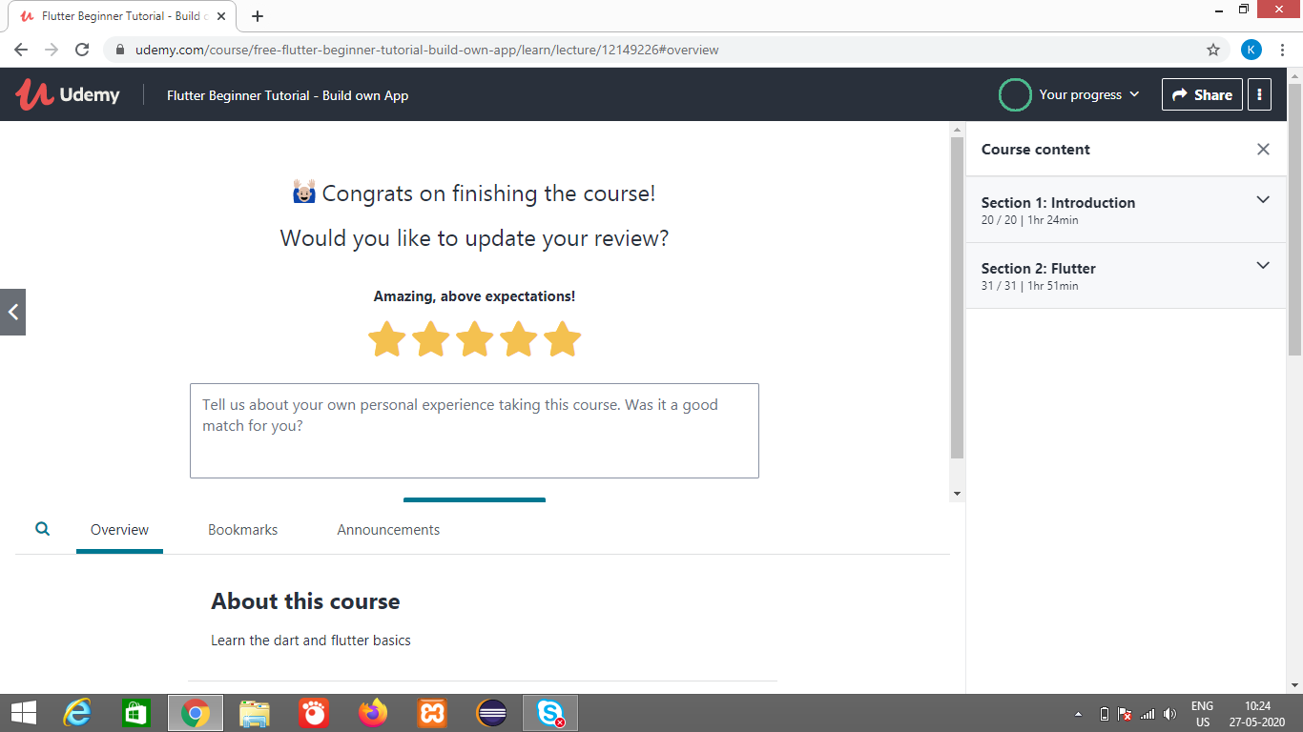

First part of the series talks about the basics of dart so beginners can get up to speed for the flutter tutorials. After that we will install android studio and start with the basics of flutter. At the end of the course we will create a simple ToDo App with basic functionallity.

- learn dart basics

- learn flutter basics

- create own app

**What we’ll learn**

* Learn the basics of dart and flutter and build an complete ToDo App

**Are there any course requirements or prerequisites?**

* For beginners. No tools required

**Who this course is for:**

* If we are interested in Flutter and App development take this course